Supply Chain Management (SCM)
Week 11 · Session 1: Supply Chain Digital Twin — Introduction, Types, Components & Use Cases
1. What is a Digital Twin?
- Definition: a virtual representation of a physical object, system or process
- It is a digital counterpart that mimics the real-world entity in terms of its:
- Attributes — properties and characteristics
- Behaviour — how it responds to inputs and conditions
- Interactions — how it connects with other elements in the system
- Created using: data from sensors, IoT devices and other sources + advanced modelling and simulation techniques
- In this course: focus specifically on Supply Chain and Operations Management digital twins

★ A digital twin is NOT just a map or visualization. It is a live, data-driven replica that also supports decision-making through analytics.
2. Types of Digital Twins in SC & Operations — Complexity Pyramid
- Complexity increases as we move up the pyramid — from product level to network of networks:

Level | DT Type & Example | Complexity
1 — Product | Digital twin of aircraft engine → monitor engine performance in real time | Lowest | ▲
2 — Process | Digital twin of oil & gas refining process → optimize process parameters, predict equipment failure, improve safety | Low | ▲
3 — Company / Enterprise | Digital twin of manufacturing company → optimize production schedules, monitor equipment health, improve overall organizational efficiency | Medium | ▲
4 — SC Network | Digital twin of food & beverage supply chain → optimize sourcing, manufacturing, distribution; ensure product quality, traceability, compliance | High | ▲
5 — Network of Networks | Interconnected system of multiple supply chains — each with own suppliers, manufacturers, distributors, customers | Highest | ▲

- Key insight: same DT concept, but scope and complexity differ dramatically across levels
- Most SC management DTs operate at levels 3–5 (company, SC network, network of networks)

3. Data Sources — What Feeds Each Level of DT
- Without data there is no digital twin. Different levels require different IT systems:

DT Level | Data Source / IT System
Product level | CAD (Computer Aided Design), CAM (Computer Aided Manufacturing)
Process level | MES — Manufacturing Execution System
Company level | ERP — Enterprise Resource Planning
SC Network level | Specialized logistics software (e.g., AnyLogistix) + external sources: logistics providers, weather data, financial market data

- SC Network level additionally integrates external data: logistics service provider data, weather forecasts, financial market data

4. Enabling Technologies for Digital Twin
- Four core technologies connect the physical system to the digital system:

Technology | Role in Digital Twin
IoT Sensors | Collects data from physical entities (temperature, location, vibration, etc.) and passes it to the digital twin in real time
Blockchain | Connects and traces parts, components and products across the supply chain — enables secure, tamper-proof traceability
AI & ML | Provides the decision support engine — optimization algorithms, demand forecasting, prescriptive analytics built into the DT
Cloud | Stores and processes vast amounts of data from multiple sources; enables high-compute AI/ML and analytics to run at scale

★ IoT = data collection. Blockchain = traceability. AI/ML = decision intelligence. Cloud = compute power. All four together enable a fully functional digital twin.

5. Three Components of a Supply Chain Digital Twin
- A SC digital twin is a virtual system comprised of three interconnected components:

DT Component | What it Provides
Digital Visualization | Geographic map showing exact locations of factories, DCs, customers. Routes between nodes. Product flow visibility.
Digital Technologies | IoT, Blockchain, ERP, Cloud — these connect physical SC with digital SC and generate the data stream.
Decision Making Support (Analytics) | Descriptive (what happened) + Predictive (what will happen) + Prescriptive (what to do) — all embedded in the DT.

Digital Visualization — What it Looks Like
- Example: 2 factories (Aurangabad, Nashik) + 2 DCs (VAPI, V1D) + 4 customers (Mumbai, Pune, Surat, Ahmedabad)
- Each node plotted on map using exact latitude and longitude → gives physical location clarity
- Routes between nodes also shown → full visual of product flow from factory → DC → customer
- Helps identify: factory location, DC coverage, last-mile routes, transport paths
- Visualization alone ≠ digital twin — it is just one component. Analytics makes it a true DT.
- Physical Supply Chain
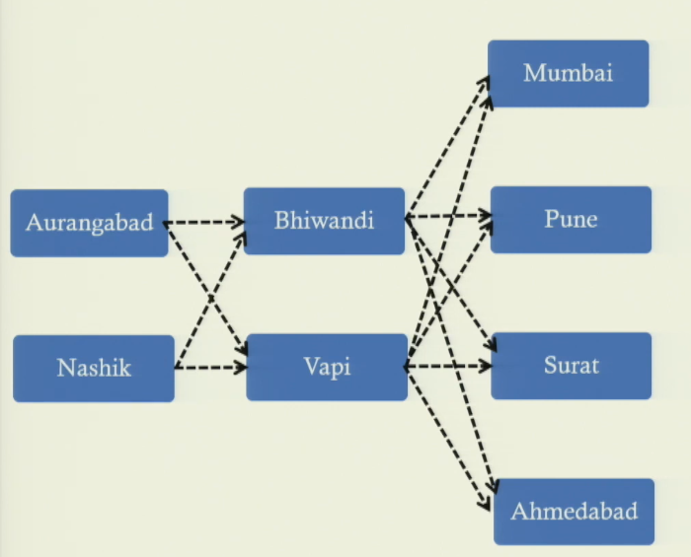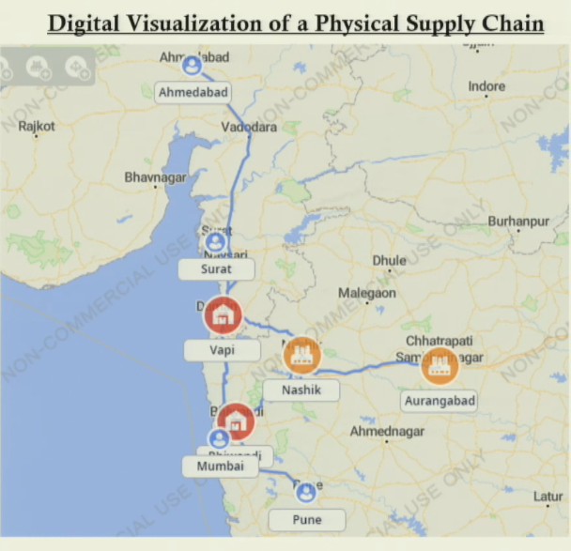

6. Decision Support — Three Levels of Analytics in a DT
- The analytics layer is what separates a digital twin from a simple visualization tool:

Analytics Type | What it Does | SC Example
Descriptive (What happened?) | Analyses historical data to understand past performance  Shows sales by product, utilization by factory, inventory trends | Product C sales were high in last 3 years. Factory A utilization was 85%.
Predictive (What will happen?) | Uses historical patterns to forecast future outcomes  Demand forecasting — will product C demand continue to rise? | Forecast shows Product C demand will rise 15% over next 2 years.
Prescriptive (What should be done?) | Recommends specific actions to optimize the system  Answers: increase factory capacity? Open new DC? Which location? How many units? | Open DC in Nagpur — serves 4 cities at minimum cost. Capacity = 20,000 units/month.

Chained Analytics Example — Product C Demand
- Descriptive: Product C sales have been high for 3 years
- Predictive: demand forecasting model says Product C will grow 15% in next 2–3 years
- Prescriptive: do I have capacity? If not — add factory or DC? Where? → optimization model answers
- Should I expand existing factory? Open a new one? Where to minimize fixed + variable cost?
- Are existing 2 DCs sufficient? If not — where to open a 3rd? Capacity? Which customers it serves?

★ Prescriptive analytics is the most powerful layer — it doesn't just tell you what will happen, it tells you WHAT TO DO about it.

7. Supply Chain Digital Twin — Use Cases
- DT acts as a digital companion for decision makers — analytically driven decisions across the entire SC:

Use Case | How DT Helps
Production Planning & Control | Decide how much of Product A, B, C to produce at which factory  Matches supply with demand — reduces supply-demand gap  Prescriptive analytics determines optimal production schedule
Inventory Control | Decide how much of each SKU to stock at each DC and customer location  Minimizes cost of overstocking + cost of understocking simultaneously  DT gives optimal inventory levels at factory, DC, and last-mile simultaneously
Shipment Control | Track truck location in real time  Decide: factory A → which DC? Which DC → which customers? How much quantity?  Optimizes routing and load planning
Quality Control | Monitor temperature + humidity in cold chain trucks in real time using IoT sensors  Alerts raised if conditions deviate from range — prevents product spoilage  Applicable to: pharma, food, blood, chemicals
Resiliency Management | If a supplier location is disrupted — DT identifies alternate supplier, location, quantity  Minimizes impact of disruption on overall SC  Prescriptive model suggests recovery plan automatically
Sustainability / Environmental Impact | Calculate CO2 emissions for a proposed SC network redesign — before implementing it  Evaluate environmental impact of new factory location, new DC, new route  Supports sustainable SC design decisions
Collaborative Planning | Collaborative demand forecasting with partners → more accurate forecasts  Collaborative sourcing planning → better supplier selection, lower cost  Transparency and traceability reduce friction in collaboration

8. Advantages of Supply Chain Digital Twin
End-to-End Visibility
- Know exact location of factories, DCs, customers, and products at any moment
- Know which routes are being used and product movement status in real time

Enhanced Traceability (Blockchain-enabled)
- Faulty product → trace which part was faulty → trace which component → trace which supplier → trace from which plant and raw material source
- Full backward trace possible: customer complaint → factory → component supplier → raw material origin

Transparent & Accurate Decision Making
- Decisions driven by real-time data + analytical models — not intuition or approximation
- Reduces human error and information gaps in SC decision-making

Better Collaboration
- Visibility and traceability make the system transparent to all partners
- Enables: collaborative demand forecasting, collaborative sourcing — improving forecast accuracy and cost
- Less under/overstocking, tighter supply-demand gap across the SC

★ DT = Visibility + Traceability + Analytics + Collaboration. It is a digital companion, not just a reporting dashboard.

Session Summary
- Digital Twin definition: virtual replica of a physical system — mimics attributes, behaviour, interactions using sensor data, IoT, modelling
- 5 types (pyramid): Product → Process → Company/Enterprise → SC Network → Network of Networks (complexity increases upward)
- Data sources: CAD/CAM (product) → MES (process) → ERP (company) → logistics software + external data (SC network)
- 4 enabling technologies: IoT (data) + Blockchain (traceability) + AI/ML (intelligence) + Cloud (compute)
- 3 DT components: Digital Visualization + Digital Technologies + Decision Support (Descriptive + Predictive + Prescriptive analytics)
- 7 use cases: Production planning, Inventory control, Shipment control, Quality control (cold chain), Resiliency, Sustainability, Collaboration
- Next session: how to develop / build a digital twin — worked examples

★ Exam Tip: 5 DT types in order: Product → Process → Company → SC Network → Network of Networks. Complexity increases at each level. Know an example for each.
★ Exam Tip: 3 DT components: (1) Digital Visualization (map + routes), (2) Digital Technologies (IoT/Blockchain/ERP/Cloud), (3) Decision Support (descriptive + predictive + prescriptive). Visualization alone is NOT a DT.
★ Exam Tip: Descriptive = what happened. Predictive = what will happen. Prescriptive = what should be done. All three must work together in a DT for full decision support.
★ Exam Tip: DT traceability (blockchain-supported): faulty product → trace part → component → supplier → plant location → raw material source. Full backward chain.

